APCO 2P99
2010/11

Project Peer to Peer

Technical Documentation

Student: Navjot Minhas
Student Number: 4097762
Supervisor: Dr. D. Hughes
Program: Bachelor of Accounting
Date: Mar 30, 2011

Project Peer to Overview:

This project is peer to peer file sharing application which connects a related set of users together and allows them to discover each other’s resources. Once a particular resource is found a user can then download it through a common protocol such as TCP.

The architecture of the network is similar to the FastTrack protocol which was utilized by KaZaa. Instead of being a decentralized network and flooding peers connected to the network with search requests similar to Gnutella, a more conservative approach has been taken, which was to be semi-centralized. In this approach Peers are categorized into two different types which are Edge and Rendezvous. Edge peers are more ad-hoc and do not propagate query request to other connected peers of the network. They are connected to rendezvous peers which are responsible for propagating search requests to other known rendezvous peers. Search requests are compared against the Rendezvous peer’s local cache of the files being shared by the connected edge peers. If a request is matched successfully, the IP address of the peer which contains the file is returned.

This project has been accomplished by using the JXTA library. This library provides the fundamental protocols needed to create a peer to peer network. The protocols which have been implemented from this library are the following: Rendezvous protocol, Peer Discovery protocol and the Endpoint Routing protocol.

Class Model:
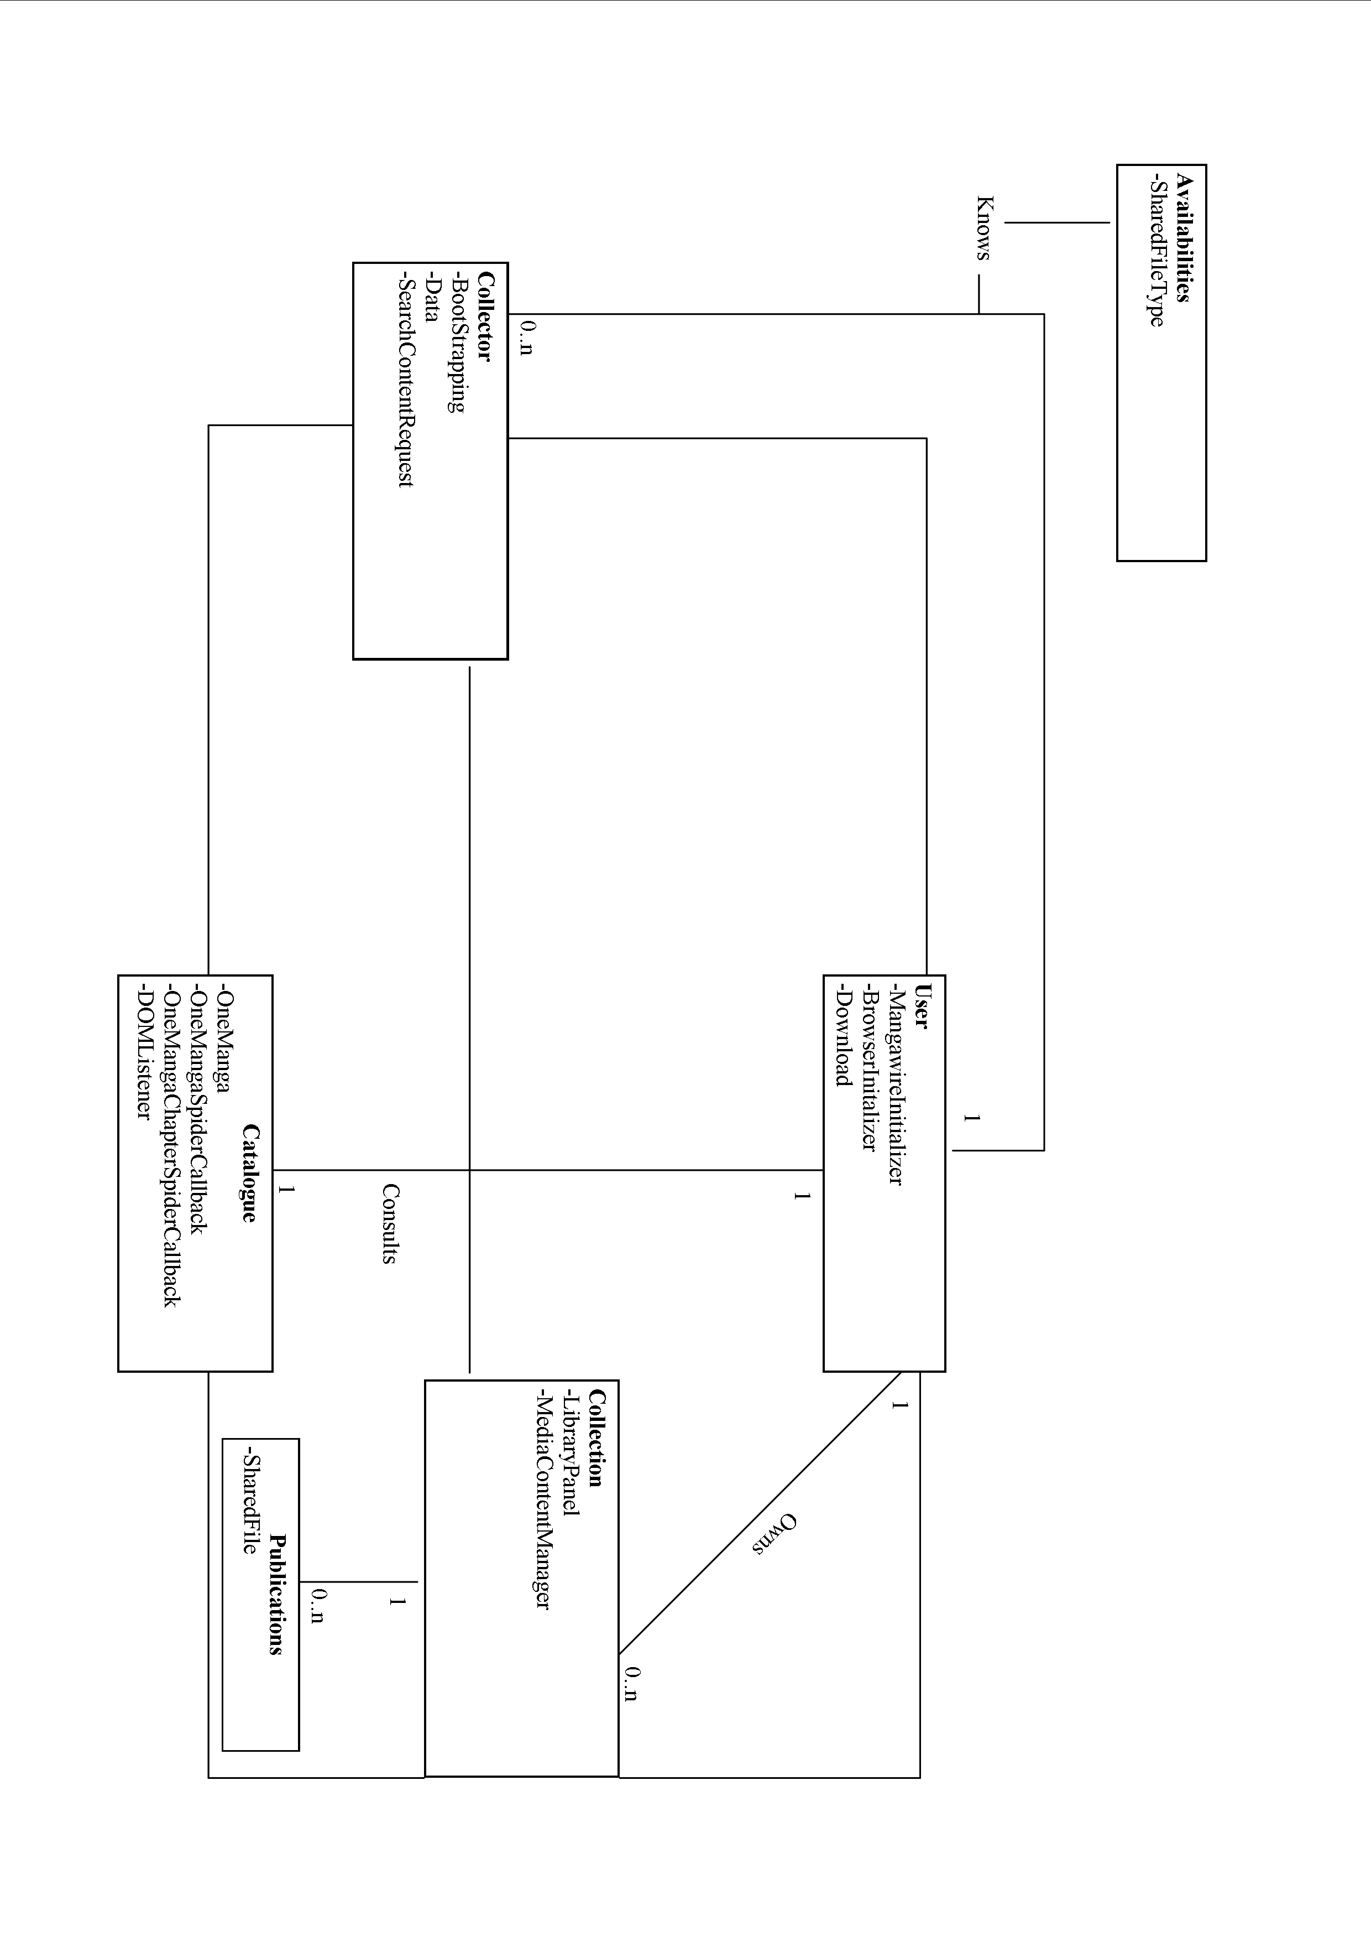

User:

Class name: MangawireInitializer
This is one of the core classes of the application and it is responsible for keeping track of the essential classes of the system. In addition, this class is responsible for initializing all the fundamental variables and setting up the application for usage.

Knowing: This class is responsible for knowing the major GUI components and the fundamental data needed to start the application. The major GUI components consist of the following:
- HomePanel: this is a class which is responsible for rendering an html page which lists the mangas that have been published.
- SearchPanel: this is a GUI class which is responsible for querying the network for available mangas/animes.
- DownloadPanel: this is a GUI class which is responsible for showing the fundamental data for a download. This includes the progress of the download, the name and size of the file, and the number of peers it is downloading from.
- LibraryPanel: this is a GUI class which is responsible for displaying of what is available in the shared folder.
- BrowserWindow: this class acts similar to an internet browser and is responsible for connecting to an online forum and rending the html page.

This class is also responsible for knowing and initializing the MediaContentManager class for setup. (This class is explained below).

Although this class must initialize all the variables stated above, it is also responsible for doing the pre-setup and post-setup phase for the application.

The preSetup function is responsible mainly for bootstrapping (which is explained in greater detail in the BootStrapping class) the application to the network and loading the catalogue. It is important to note the difference between mangas available in the catalogue and mangas available in the network. Generally, the mangas listed on the home panel are a snap shot of mangas that have been published; however, they are not guaranteed to be available on the network.

The postSetup function is responsible for the setup once the interface is visible to the user. This includes loading the forums in BrowserWindow, installing the DOMListener on the HomePanel and initializing the MediaContentManager.

It is important to remember that each setup operation is performed on a separate thread, in order to avoid doing calculations on the Event Dispatch Thread.

Class name: BrowserInitializer
This class does not keep track of any variables. Its main function is to resolve the directory which contains the XUL Runner files and set it as one of the global library paths. The XUL Runner files are dependency files which the BrowserWindow class and the HomePanel class require in order to render html content. In other words, any class which renders html content in the application is dependent on the BrowserInitializer.initialize() function being invoked before the class can display any content.

Class name: Download
This class is responsible for downloading content to the local shared folder. Although this class is mainly for downloading, it has many other smaller responsibilities before a download operation can be executed successfully. One objective this class must perform before a download is performed is to check the existence of a file with the same name. If a file exists with the name, the Download class will append a numerical value to the end of the file name that will be downloaded. It will then create an empty file based on the new file name generated. Furthermore, it is responsible for providing feedback to the user, this would include file name, progression of the download, the status of the download, and the transfer rate. The downloading is performed by the JXTA-CMS library. It downloads the file by utilizing the file object created earlier and the retrieving the ContentAdvertisments(Can be metaphorically referred to as the end point address of all the different peers ) stored in the SharedFileType object.

Availabilities:

Class name: SharedFileType
The SharedFileType class is a class which keeps track of a single search result displayed on the SearchResultPanel. This class is only responsible for keeping track of the attributes for a single search result. The attributes of a search result are the following:
- Hash value
- File Name
- Description
- The endpoint address of all the different peers which have the given file
- Language
- Series
- Type
- File size
The class does not provide any functionality; however, the Download class is dependent on all the information collected in this class for when a download is being performed.

Collector:

Class name: Data
This class is a “knowing” class and has no functions.The main purpose is to provide the whole system with the most important primitive variables needed for all P2P classes to function properly and for other parts of the application. The variables which it statically stores consist of the following:
- downloadDirectory: This is a file variable referencing the structured shared folder. Other main classes which are dependant on this variable are the download class and the library panel class.
- PEER_GROUP: this variable is of type PeerGroup and stores the peer group level of the program. Peer groups are formed as a collection of peers that have agreed upon a common set of services (downloading and sharing mangas). Each peer group is assigned a unique peer group ID and a peer group advertisement. It is the most fundamental variable throughout the system since it provides the application with access to all of the JXTA services.
- Mangas: this variable is a HashMap. It is responsible for storing all the different mangas along with their associated URLs that have been extracted from the external resource. The HomePanel class is dependant on this variable because it uses data stored in the hash map to render the different html pages.

Class name: BootStrapping
This class is responsible for connecting the application to the network. It provides the system with the PeerGroup variable which is needed to utilize all the JXTA services available. Once it obtains the net peer group variable it searches for MangaGroup which is a child peer group of the net peer group. This is done by utilizing the discovery service of the net peer group. However, in order to obtain the net peer group, it is required that the application connects to a seed. A seed is a dedicated rendezvous peer which is always connected to the network. Its function is to allow a connecting peer to discover the existence of other connected peers. A dedicated IP address for the seed must be known for the application to connect to the network. If the application in not able to successfully connect to the seed within 4 minutes it will exit the application.

Class name: SearchContentRequest
This class performs an instance of a search on the network. It is responsible for generating a list of results and determining whether one or more advertisements are the same. It is important to consider that if an advertisement has the same hash value but has different end point addresses they are considered to be the same advertisement from two different peers. With this approach, it is possible to have concurrent downloads similar to bit torrent downloads. The generated results are stored in a hash map which uses the advertisements hash value as a key and stores a SharedFileType object as the value. Keeping track and updating results to the hash map is the responsibility of this class. The Download class is dependent on the HashMap because it provides the file metadata along with IP addresses of the peers who have the file. In other words, the Download class needs the results HashMap to lookup the basic file downloading information. One thing to note when using the JXTA library is that there is a one to one relationship between the peer group and the discovery service. However, there is a one to many relationship between the discovery service and the number of searches it can perform. This means that the discovery service can perform multiple concurrent searches. Although this has its advantages, it also has a disadvantage which is determining the query associated with the result. Another function of the class is to associate the events fired by the discovery listener to the query before adding it to the results HashMap.

Collection:

Class name: SharedFile
This class is an extension of the java.io.file class. However, new functions have been added to this library, which provide the file’s series, type, and language. This information is essential when a file’s metadata is being published by the MediaContentManager class on to the network.

Class name: MediaContentManager
The class media content manger has many responsibilities. It is responsible for knowing the list of files in the shared folder. Furthermore, its main function is to publish the metadata of all the shared files. The purpose of publishing the metadata on to the network is to make other peers aware of the shared file’s existence. Each shared file is published with its name, size, computed hash value, series, type, and language. It is key to note that hash values are calculated each time the startSharing() method is invoked. Another responsibility the MediaContentManager has is to unshare all shared files when the application shuts down. This is to help keep the network up to date and give other peers accurate results for their queries. Lastly, this class is responsible for publishing the metadata of any files downloaded during the lifecycle of the application. Once the Download class has downloaded a file it will use the publishFile(File sharedFile) method to publish the file’s metadata.

Catalogue:

Class name: OneManga, OneMangaSpiderCallback, OneMangaChapterSpiderCallback
All three of these classes are responsible for extracting data from the site OneManga.com. The responsibility of the OneMangaSpiderCallback class is to extract all the different mangas from the site. The OneMangaChapterSpiderCallback gets all chapters of a given series. The OneManga class is the mediator between the two classes and is responsible for keeping track of the results returned by both classes. It is used by the DOMListener class to write the dynamic html pages for the chapters overview, and it is used by the HomePanel class to create the source code for the main html page.

Class name: DOMListener
This class is a listener which fires an event when a “click” has been performed on an anchor tag in the HomePanel page. Once it evaluates the hyperlink reference attribute associated with the anchor tag, it then executes either a search on the SearchPanel or it will display a list of associated chapters on the HomePanel.

Package Summary:
net.managwire.browser | This package contains all the necessary classes to initialize and show the instance of a Mozilla browser.
net.managwire.common | This package contains classes which provide static data for the whole application.
net.managwire.components | This package contains custom GUI components.
net.managwire.components.button | This package contains custom GUI buttons.
net.managwire.components.field | This package contains custom GUI text input fields.
net.managwire.components.label | This package contains custom GUI labels.
net.managwire.components.panel | This package contains GUI panes.
net.managwire.components.splashscreen | This package contains all the GUI classes required for the splash screen to be displayed and animated.
net.managwire.components.tablecellrender | This package contains all the GUI classes required to render the custom table cells.
net.managwire.downloadmanager | This package contains all the classes for the download panel. This includes the classes for downloading a file from a user.
net.managwire.errorlog | This package contains the error console which is only enabled for debugging purposes.
net.managwire.homepanel | This package contains all the classes for the HomePanel. It contains the class which renders the HTML on the homepage, and writes the HTML in a canonical form in order to trigger the DOMListener.
net.managwire.library | This package contains all the classes used for handling, filtering and sorting the files in the shared folder.
net.managwire.library.table | This package contains the GUI and Non-GUI classes required to initialize the main library table.
net.managwire.mainframe | This package contains the main method which sets up the entire application. It has contains the class which is used to assemble the main user interface together.
net.managwire.search.table | This package contains all the classes used for handling, filtering and sorting the search results. It also contains the classes for displaying the initial Search Panel which the sliding advertisements.
net.managwire.ui | This package contains the UI delegates required by the custom GUI components.
net.managwire.ui.button | This package contains custom button UI delegates.
net.managwire.ui.tabbedpane | This package contains custom tabbed pane UI delegates.
net.mangawire.p2p.content | This package contains all the p2p classes used in the application. This includes searching, bootstrapping and sharing.
net.mangawire.parser | This package contains the classes for the OneManga parser which extracts all the manga metadata listed on Onemanga.com
net.mangawire.parser.spider | This package contains the callback classes used by the OneManga parser.
net.mangawire.type | This package contains the data classes which represent a search result.

Build:
To build the project, it must be imported into the Netbeans IDE first. Once it is imported, use the Netbeans clean and build function to create the distributable JAR file. This process will create a ‘dist’ sub folder in the project home. In the ‘dist’ folder will be the Mangawire.jar file and a lib folder which contains all the java dependencies. However, there are a few dependencies which are still missing and are required for the program to launch successfully. In order to successfully run the application, copy and paste the ‘dependencies’ folder and the XULRunner.zip file from the project home folder into the ‘dist’ folder. The last step is to create a new folder in the ‘dist folder’ named ‘MangaWire’. This folder will be the shared folder where all the downloaded/shared files will be stored. Once these preparations are done the application can be launched successfully.

How to test the project:
- Before running the Mangawire.jar file, execute the rendezvous peer first. This will allow more then one peer to be run locally on a machine and connect to each other. It is recommended that the rendezvous peer is executed through the command line. In order to use the command line, the user must first change directories to where the p2p.jar file is located (cd <full directory path of the p2p.jar file>). Then in order to execute the file, use the following command (java –jar p2p.jar). This should show all the debugging information in the command console.
- Then the developer has the option of either building the jar file as explained above or using the IDE’s test function. To run the jar file through command prompt use the same commands outlined for the step above but however each command should be in respect of the Mangawire.jar file. (See video 2)

Common Modification

How to change the forums loaded? In order to change the forums loaded, the URL must be changed in the post setup phase of the application. The post setup is done in the MangawireInitializer class. When the class calls the method load(String URL) for the browser instance variable, the string parameter must represent the URL of the forum. Thus, in order to change the forum’s location, replace the following string parameter http://forum.onemanga.com/ with a new String URL.

How to change the Cascading Style Sheet of the home page? The Style sheet of the main home page is located in the following directory: {ProjectHome}/dependencies/assets/css/main.css. In order to change the style sheet open the file in a text editor and change the attributes. Some key attributes to know are the following:
- navigationButton: This represents the buttons that are at the top of the page.
- main: This represents the main block where all the content is displayed and handled.
- footer: this tag represents the bottom block of the Div tag with the main attribute.

How to change the Home Panel HTML file:
The main page’s HTML source is located at the following directory: {ProjectHome}/dependencies/index.html. However before changing the html file there are some constraints that need to be considered.
- The header information should not be changed as it contains a canonical representation of the CSS style sheet paths and JavaScript file path. These conical forms get resolved during the execution of the application.
- The canonical string representation {series} must be written somewhere in the body tag between a pair of definition list tags. It requires the definition list tags in order to make the drop down list as seen in the home panel. The {series} variable indicates to the application where it must insert the generated code for the list of mangas available.

How to change the HomePanel Chapter overview window:
The chapter overview HTML page is located in the following directory: {ProjectHome}/dependencies/temp.html. Similar to the main html page, this also has constraints which must be considered:
- The header information should not be changed as it contains a canonical representation of the CSS style sheet paths and JavaScript file path. These conical forms get resolved during the execution of the application.
- The canonical string representation {chapter list} must be written somewhere in the body tag between a pair table body tags. This representation will indicate to the program where to insert the generated chapters list.
- The {summary} string representation must be written between definition list tags. This representation will indicate to the application where to insert the summary of the manga.

How to change the Cascading Style Sheet Chapter Overview:
The Style sheet of the chapter overview page is located in the following directory: {ProjectHome}/dependencies/assets/css/main_2.css. A key summary of the important identifiers are:
- main: This represents the main block where all the content is displayed and handled.
- clip: This attribute puts a white border around the image of the manga series logo.
- container: This block holds the logo and the list of chapters in the series.

Future Extensions

Creating a UDP host cache:
Instead of always connecting to a seed, it would be better if there was a UDP server that sent a list of active rendezvous peers in the network once during the application’s first run. This means that the very first time MangaWire runs on a machine it will ping a predefined DNS address which in turn will pong a list of active rendezvous peers.

Faster hashing method:
When a file is being shared its hash must first be computed. However, hashing a 200 megabyte file with the SHA-256 hashing algorithm is very time consuming. It takes approximately 30 seconds per file of this size. It would be more beneficial if there was a faster way of determining the hash of a shared file. A solution which might help with this problem is computing the hash only for a portion of the file, similar to the UUHash algorithm developed by KaZaa. However, the disadvantage of this method is that it causes a greater probability of collisions. This means that it is possible to have two different files which produce the same hash string.

Automatic Update Feature:
A feature which would automatically update the application without the user doing it manually through the website. This would help change the protocol if new features needed to be added to the network. For example, if there is an introduction to a new hashing algorithm for verifying the file. This feature would help clients easily update there application to be compliant with the new network specifications.

